Climate Data Analysis for Station AL007

# Abstract

In 2015 at station AL007, the maximum and minimum temperatures differed by 35.855°C, with the highest maximum temperature recorded in July at 36.748°C and the lowest minimum temperature in December at 0.893°C. For precipitation, the most frequent value (mode) throughout the year was consistently 0.0 mm, indicating a predominantly dry year. Regarding atmospheric pressure in 2014, March exhibited the greatest discrepancy between maximum and minimum values, with a difference of 40.70 mbar, showcasing significant variation in atmospheric conditions during that month.

# By how much do the maximum and minimum values of the temperature differ in year 2015 for station AL007?

To determine the difference between the maximum and minimum temperature values for the year 2015 at the station AL007, we need to look at the temperature data for each month and identify the highest maximum temperature and the lowest minimum temperature recorded during that year.  
  
Here is the relevant temperature data for 2015:  
  
- January: Max 16.687, Min 1.366  
- February: Max 18.713, Min 1.922  
- March: Max 20.869, Min 5.219  
- April: Max 23.514, Min 5.237  
- May: Max 32.546, Min 11.182  
- June: Max 33.008, Min 16.541  
- July: Max 36.748, Min 21.232  
- August: Max 36.51, Min 18.28  
- September: Max 34.229, Min 13.602  
- October: Max 26.302, Min 10.06  
- November: Max 22.563, Min 4.251  
- December: Max 16.605, Min 0.893  
  
From this data:  
  
- The highest maximum temperature in 2015 is 36.748°C (July).  
- The lowest minimum temperature in 2015 is 0.893°C (December).  
  
The difference between the highest maximum temperature and the lowest minimum temperature is calculated as follows:  
  
Difference = Highest Max Temperature - Lowest Min Temperature  
Difference = 36.748 - 0.893  
Difference = 35.855  
  
Therefore, the maximum and minimum values of the temperature differ by 35.855°C in the year 2015 for station AL007.

# What was the most frequent value (mode) of the precipitation in year 2015 for station AL007?

To determine the most frequent value (mode) of precipitation for the year 2015 at station AL007, we need to look at the mode precipitation values for each month in 2015:  
  
- January 2015: Mode = 0.0 mm  
- February 2015: Mode = 0.0 mm  
- March 2015: Mode = 0.0 mm  
- April 2015: Mode = 0.0 mm  
- May 2015: Mode = 0.0 mm  
- June 2015: Mode = 0.0 mm  
- July 2015: Mode = 0.0 mm  
- August 2015: Mode = 0.0 mm  
- September 2015: Mode = 0.0 mm  
- October 2015: Mode = 0.0 mm  
- November 2015: Mode = 0.0 mm  
- December 2015: Mode = 0.0 mm  
  
The most frequent value (mode) of precipitation for each month in 2015 at station AL007 is consistently 0.0 mm. Therefore, the mode precipitation value for the entire year 2015 is 0.0 mm.

# In which month of year 2014 does the pressure show the greatest discrepancy between its maximum and minimum values for station AL007

To determine the month in 2014 with the greatest discrepancy between the maximum and minimum pressure values for station AL007, we need to calculate the difference between the maximum and minimum pressure for each month and identify the month with the largest difference.  
  
Here is the breakdown of the differences for each month:  
  
1. January 2014: Max: 1029.13, Min: 995.54  
 Difference = 1029.13 - 995.54 = 33.59  
  
2. February 2014: Max: 1022.76, Min: 1003.23  
 Difference = 1022.76 - 1003.23 = 19.53  
  
3. March 2014: Max: 1028.87, Min: 988.17  
 Difference = 1028.87 - 988.17 = 40.70  
  
4. April 2014: Max: 1021.1, Min: 1000.12  
 Difference = 1021.1 - 1000.12 = 20.98  
  
5. May 2014: Max: 1021.78, Min: 1002.14  
 Difference = 1021.78 - 1002.14 = 19.64  
  
6. June 2014: Max: 1022.32, Min: 1007.71  
 Difference = 1022.32 - 1007.71 = 14.61  
  
7. July 2014: Max: 1023.3, Min: 1004.48  
 Difference = 1023.3 - 1004.48 = 18.82  
  
8. August 2014: Max: 1017.3, Min: 1008.48  
 Difference = 1017.3 - 1008.48 = 8.82  
  
9. September 2014: Max: 1028.51, Min: 1002.38  
 Difference = 1028.51 - 1002.38 = 26.13  
  
10. October 2014: Max: 1025.86, Min: 1003.34  
 Difference = 1025.86 - 1003.34 = 22.52  
  
11. November 2014: Max: 1026.91, Min: 1004.33  
 Difference = 1026.91 - 1004.33 = 22.58  
  
12. December 2014: Max: 1031.99, Min: 996.25  
 Difference = 1031.99 - 996.25 = 35.74  
  
The month of March 2014 shows the greatest discrepancy between its maximum and minimum pressure values with a difference of 40.70 mbar.

# Data

Summary Table:

|  |  |
| --- | --- |
| Question | Numerical Data |
| Summary | 35.855 |
| ModePrecipitation | 0.0 |
| GreatestDiscrepancyPressure | 40.70 |

# Grafici dei Dati

Summary

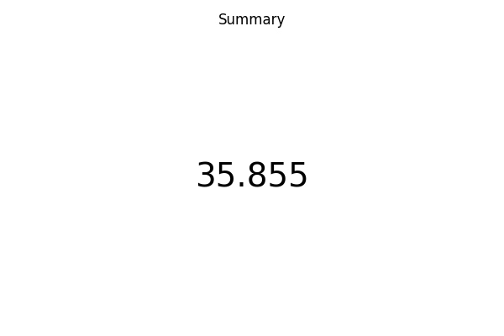

ModePrecipitation

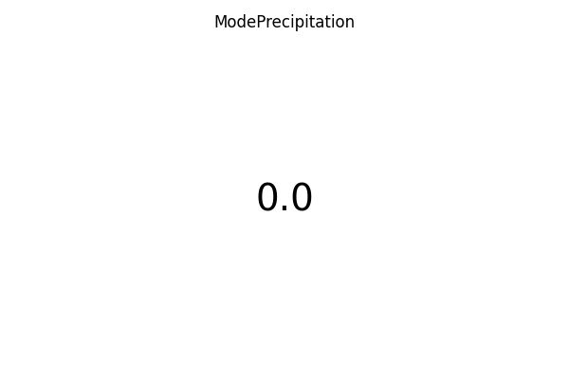

GreatestDiscrepancyPressure

